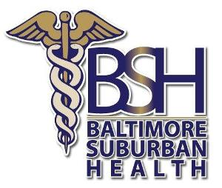
BALTIMORE SUBURBAN HEALTH, LLC
NOTICE OF PRIVACY PRACTICES:

ACKNOWLEDGEMENT OF RECEIPT

By signing this form, you acknowledge receipt of the Baltimore Suburban Health Notice of Privacy Practices. Our Notice of Privacy Practices provides information about how we may use and disclose your protected health information. We encourage you to read it in full.
I acknowledge receipt of the Baltimore Suburban Health Notice of Privacy Practices.
Signature: ________________________________ Date: _____________________
(patient/parent /conservator/guardian)

INABILITY TO OBTAIN ACKNOWELDGEMENT
To be completed only if no signature is obtained. If it is not possible to obtain the individual’s acknowledgement, describe the good faith efforts made to obtain the individual’s acknowledgement, and the reason why the acknowledgment was not obtained:
Signature of provider representative: ______________________________Date:___________________

PATIENT ACCT#:_______________________________

